Preparation

Things required:

1x MicroBit

1x Joystick Bit for microbit

Unity

Assets

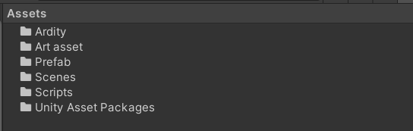

Ardity-Does the job of handling the connection between the microbit and the computer through the COM ports

Link - <https://ardity.dwilches.com/>

Art asset - Things that is gotten from online/self-made

Prefab - Allows you to create, configure, and store a GameObject complete with all its components, property values, and child GameObjects as a reusable Asset.

Scenes - All the game scenes

Scripts - All the C# codes written

Unity Asset Packages - All the asset that is gotten from the Unity asset store

Scripts

Comments is written inside each script to provide assistance to understand how the code works

Microbit:

Step 1: Download the script into microbit from [here](https://makecode.microbit.org/_Tmwct9FJpTMT).

Step 2: Put the microbit and joystick bit together and connect into your computer ports

Step 3: Go [download from GitHub](https://github.com/tinkercademy/3D-Shooter-Game_Microbit-Unity) and extract the files

Step 4: Go to 3D-Shooter-Game_Microbit-Unity->3D-shooter-unity and extract the Game_Window.zip

Step 5: Run the Application inside that folder and you can play the game.

How to win the game

Kill the boss in the shortest time possible